Naomi Slipp

**Evans, Walker (1903-1975) Word Count: 556**

Walker Evans is an American photographer, best known for his work for the Farm Security Administration during the American Depression. His documentary style, historically regarded as detached, is now viewed as an honest and engaged reflection of Evans’s own point of view. Born in St. Louis, Missouri, to an affluent family, Evans studied literature at Williams College before moving to Paris in 1926. In 1928 Evans moved to New York City, and, citing Eugene Atget as an influence, began taking photographs. He was given a solo exhibition at the Julien Levy Gallery in 1932. The following year he travelled to Havana. The photographs taken there, which were published in *The Crime of Cuba* (1933) alongside text by journalist Carleton Beals, reveal a country in the midst of revolution. Two years later, Evans began working for *Fortune* magazine, eventually contributing over 400 images to the publication before his departure in 1965. Evans’s penetrating documentary images express an interest in the everyday lives of individuals and uniquely balance both intimacy and detachment; his photographs of the Depression are considered some of the most iconic images of that era.

A 1935 commission for the U.S. Department of the Interior to photograph a community of unemployed coal workers in West Virginia developed into a full-time position for Evans with the Resettlement Administration, later the Farm Security Administration. Working under director Roy Stryker until 1938, Evans perfected his documentary technique while photographing small-town America. In the summer of 1936, on leave from the FSA, Evans travelled **to** Alabama with writer James Agee to photograph three sharecropper families—the Burroughs, Tengles, and Fields—for *Fortune*. Evans’s intimate photographs of family members and their possessions reveal the intense poverty facing white sharecroppers during the Dust Bowl. While *Fortune* rejected the article, the project was published as *Let Us Now Praise Famous Men* in 1941. Evans’s sobering frontal portrait of Allie Mae Burroughs, set against the clapboard siding of her rural home, has become an iconic symbol of the Great Depression and female resilience.

In 1938, Evans received the first monographic photography exhibition at the Museum of Modern Art in New York City, which displayed his FSA photography and was accompanied by a catalogue with an essay by his friend, cultural impresario Lincoln Kirstein (1907-1996). The same year, Evans began a series of portraits taken with a camera concealed under his coat in the New York City Subway system. These candid and sometimes alarmingly voyeuristic images were published in *Many Are Called* (1966). In 1965, Evans was appointed professor of photography at Yale University, a post that he held until 1974. Evans died a year later in Lyme, CT.

A towering figure, Walker Evans influenced later generations of photographers, including those he mentored like Helen Levitt (1913-2009). A signal of that influence is his appropriation by postmodernist photographers, such as Sherrie Levine (1947--), whose 1981 *After Walker Evans* series re-photographed Evans’s work, including his iconic portrait of Allie Mae Burroughs. In their attempts to rewrite the photographic canon, Walker Evans became a prime target for such postmodernist interventions.

**List of works**

Evans, W. and Agee, J. (1941) *Let Us Now Praise Famous Men,* Boston: Houghton Mifflin.

**References and further reading**

Rosenberg, J.L., Hambourg, M.M., Eklund, D., and Fineman, M. (2000) *Walker Evans*, Princeton, NJ: Princeton University Press.

Galassi, P. (2002) *Walker Evans & Company*, New York: The Museum of Modern Art.

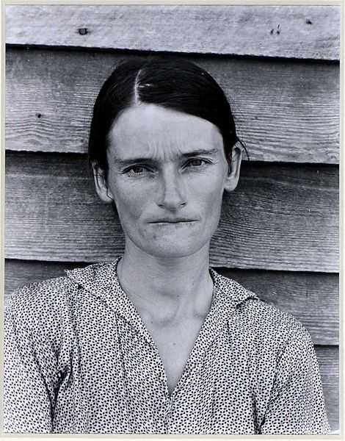

**Allie Mae Burroughs, Hale County, Alabama, 1936.** Gelatin-silver print.

Victoria & Albert Museum (http://collections.vam.ac.uk/item/O93825/allie-mae-burroughs-hale-county-photograph-evans-walker/)